CLASS: XII CYCLE TEST- BIOLOGY MARKS : 20
DATE: 5.9.19 Time: 40min
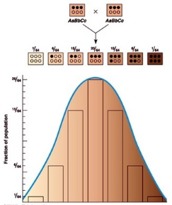
I. Answer the following questions: (5x1=5)
1. What type of inheritance is determined by multiple genes located at different loci on chromosomes and there can be a range trait?
a. Co-dominance b.Incomplete dominace
c. polygenic inheritance d. all of these

2. In drosophila (fruit flies), eye colour is sex-linked and red eye colour is dominant to white eye colour. Which of the following are not possible in a cross between a red-eyed male and a heterozygous female?
a. Red-eyed male. b. White-eyed male.
c. Carrier female. d. Homozygous white-eyed female.
3. In a genetic cross having recessive epistasis, F₂ phenotypic ratio would be
a. 9:6:1 b. 15: 1 c. 9: 3: 4 d.12: 3: 1.
4. The chromosomal theory of inheritance violates which of the following laws?
a. Law of dominance b. Law of segregation
c. Law of independent assortment d. None
5. Which of the following doesn’t agree with the chromosomal theory of inheritance?
a. The genes are located on the chromosome
b. The genes on the same chromosome are always passed together
c. The genes are located linearly on the chromosomes
d. The distance between two genes can be mapped
6. What are hypostatis genes? (2)
7. Why do we get walnut type comb when we crossed pea type and rose type comb in fowls? (3)
8. Maximum height of the plant is 30ft and minimum height is 10ft. If plant height is controlled by 3 pairs of genes. (5)
a. Identify the type of gene inheritance or expression.
b. Draw the Punnett square for the above one.
c. Mention the phenotypic ratio.
9. Explain about the eye colour inheritance of Drosopilla melangaster. (5)

